**WEBSITE CONTENT:**



The **Zero Hunger** initiative/campaign is extremely relevant for Indiaas India has been facing hunger crisis for a long time. As per the Global Hunger Index report 2020 India ranked 94 out of 107 countries - with the hunger level in the country categorized as "SERIOUS”. Our country is also home to 25 percent of the world's hungry population.

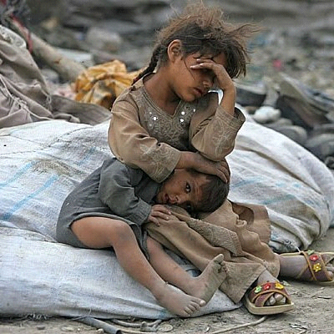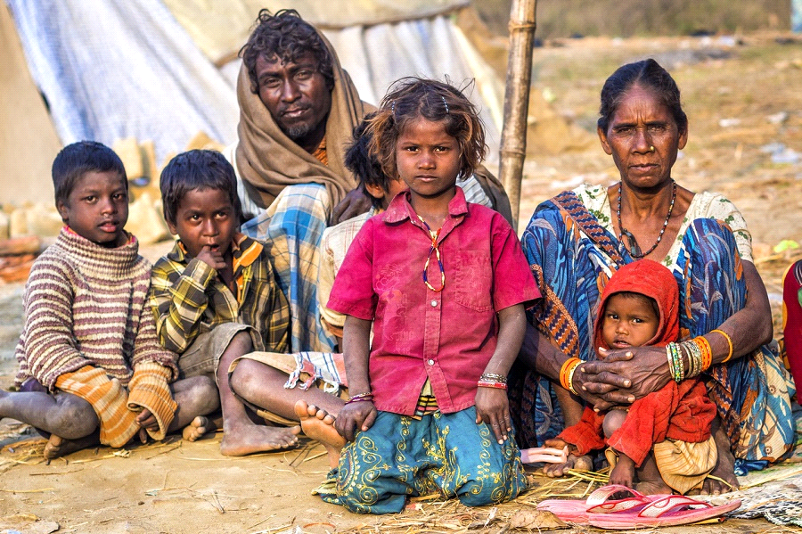

**Covid has compounded the issue:**

The food stress existed long before the start of the pandemic. It has become worse during COVID time. Many people have lost their jobs, and those with low incomes complain about food insecurity. Families already in deep distress due to lack of livelihoods, reduced income, no access to sufficient food. Hunger is a continuous disaster for large parts of our population.

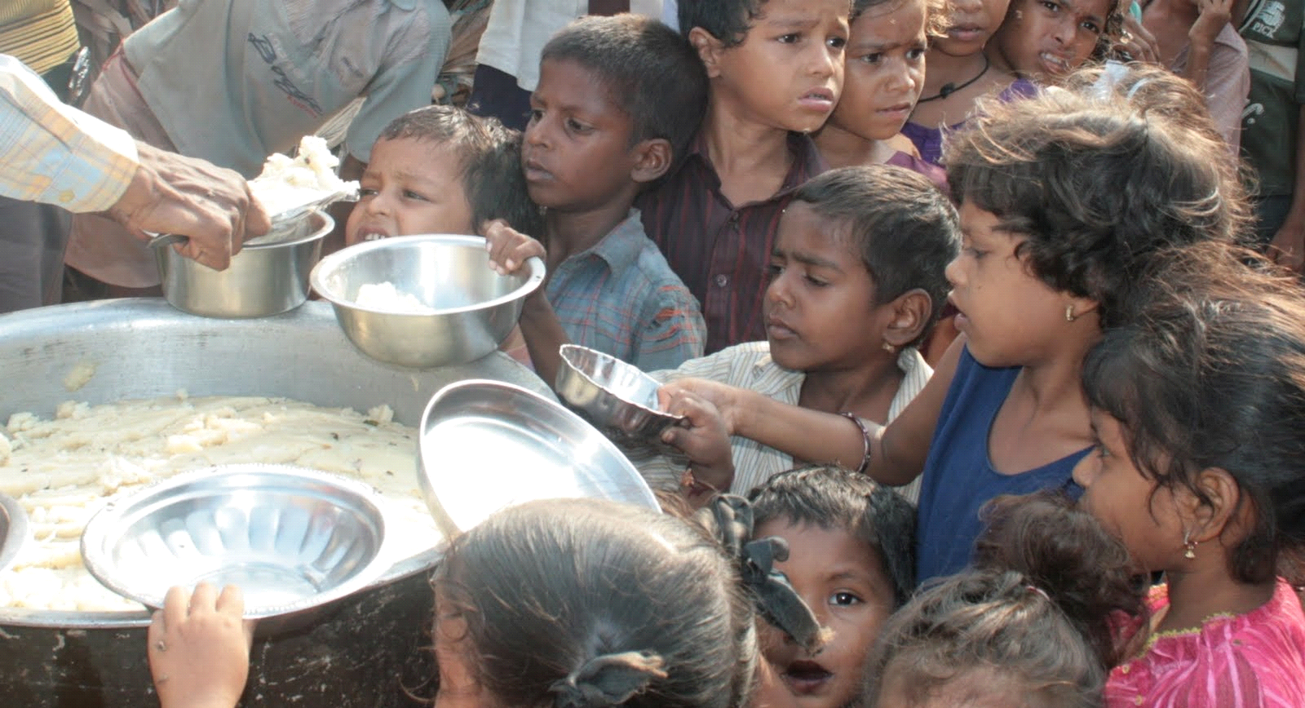

**Food Wastage:**

Everyone talk about hunger as key issue in our country, only few are concerned about food wastage which is a horrendous problem, so is food waste management in India. Indians waste the maximum amount of food as much as the whole of the UK consumes. In India, the larger the marriage, the larger the party, and also the additional stupendous the waste. No doubt weddings and banquets are an enormous supply of food wastage; however, restaurants and hotels conjointly contribute to food wastage.

On Average, 40% of food produced were being disposed of. This means that 7.5 tons of food are discarded daily.

Some 84.7% of the whole waste material recorded was thrown within the bin, whereas the remainder was either fed to the poor or some animals.

A big portion of the waste material binned was still in edible condition.

If the edible waste material generated is used, we tend to estimate that it might feed a minimum of 2000 individuals daily.

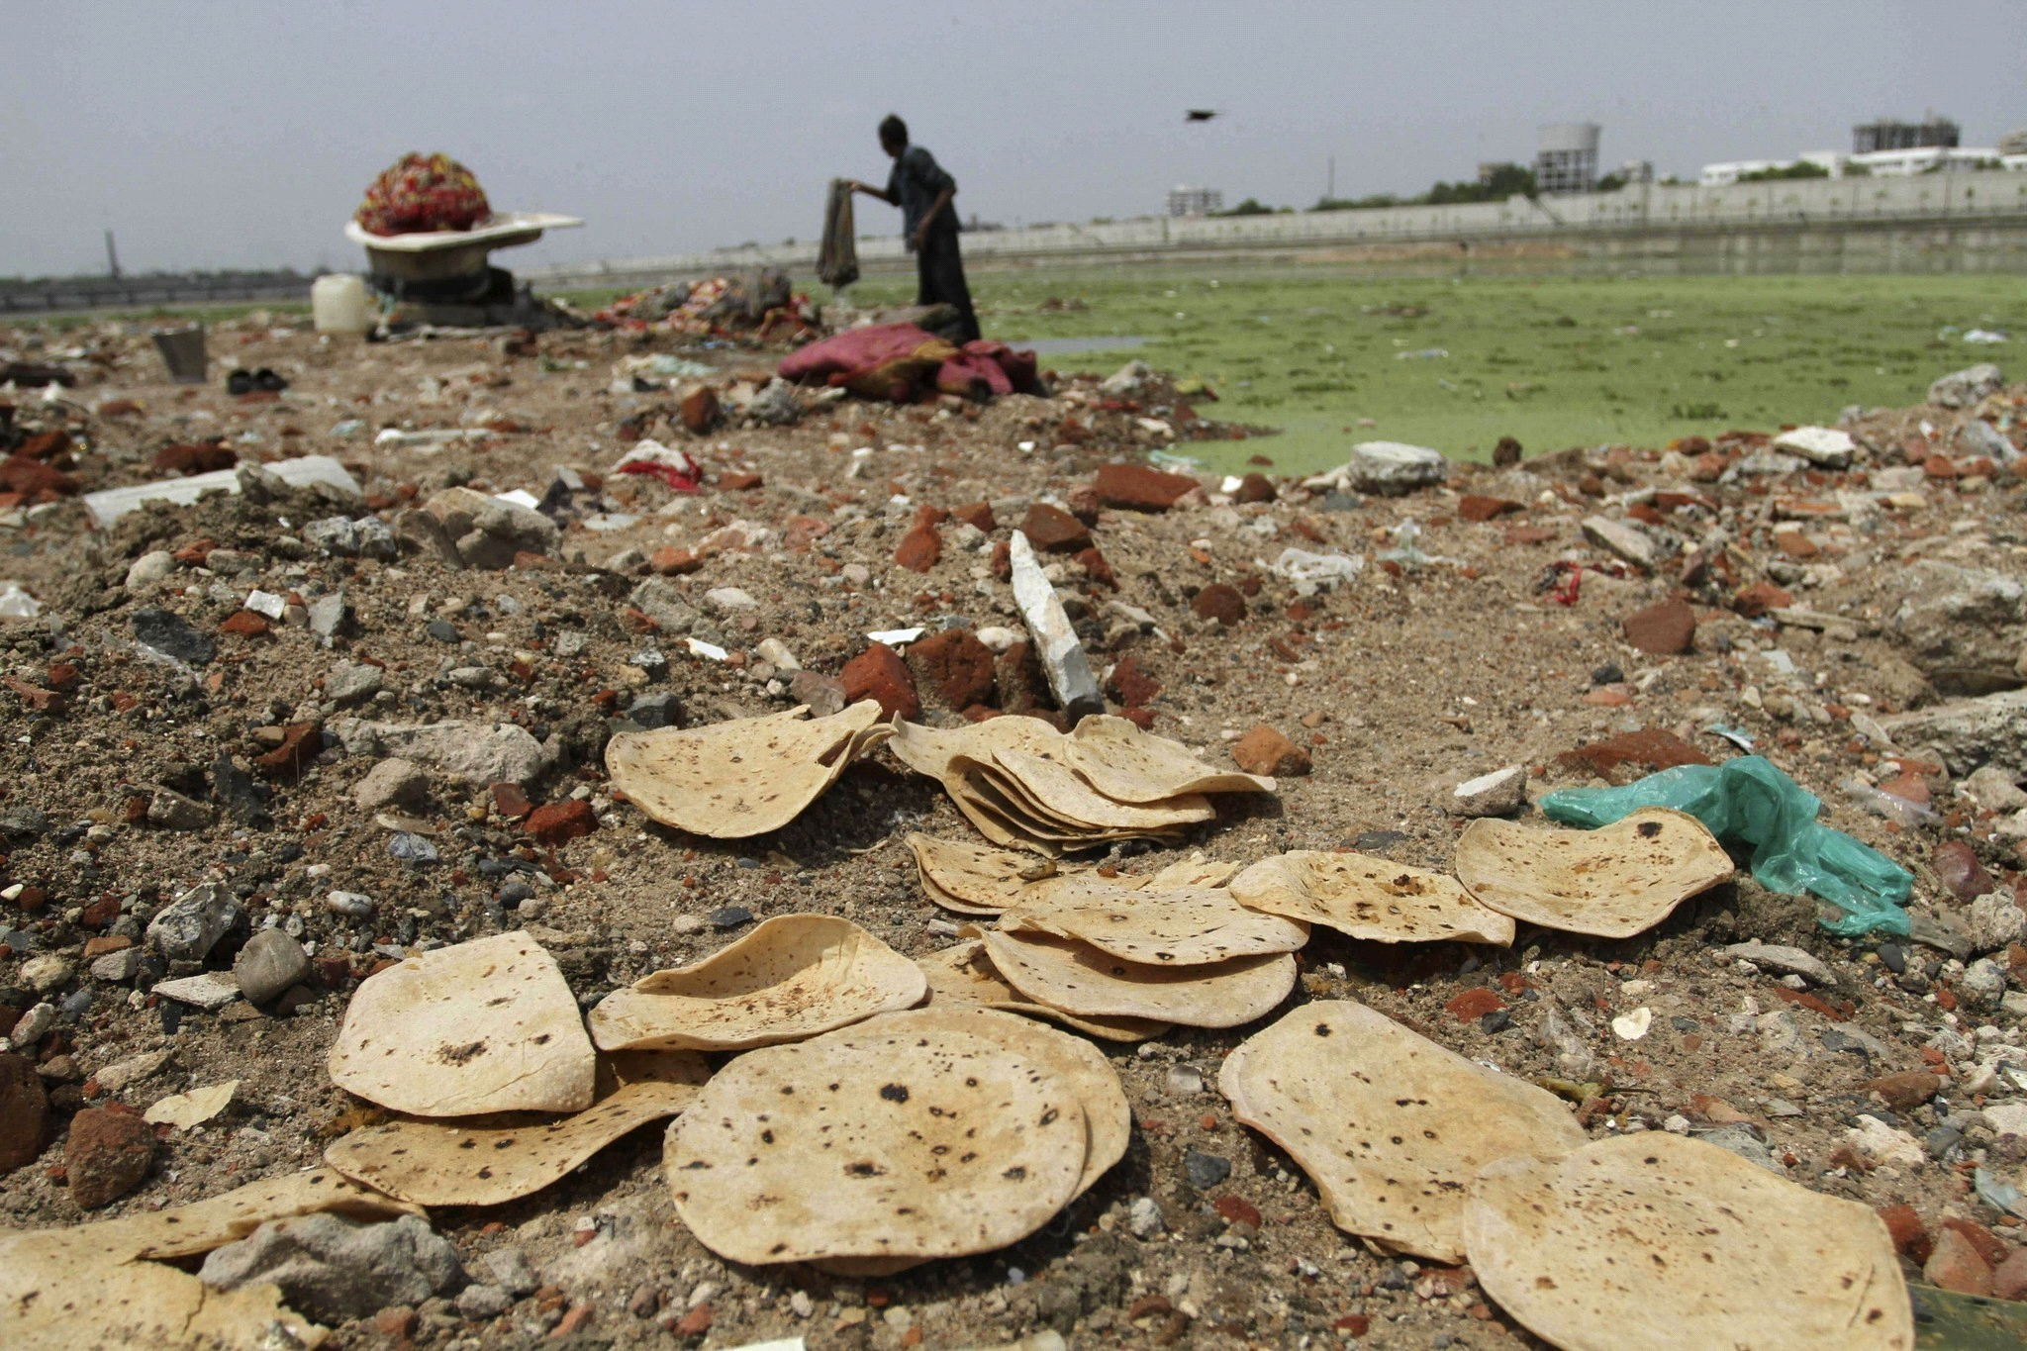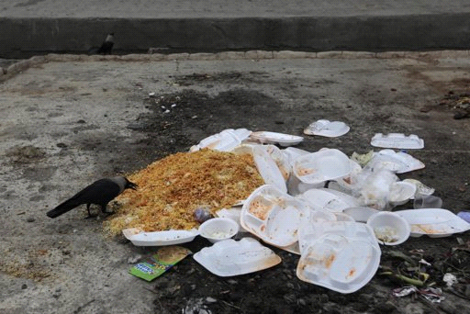

**OUR VISION:**

**1. Bridging the gap between food donors and NGO's:**

IncrEDIBLE Bytes provides a platform for people to post information regarding the leftover food rather than chucking it away. On the other hand, NGO's can use the same platform to connect with these people, collect food and provide it to needy ones.

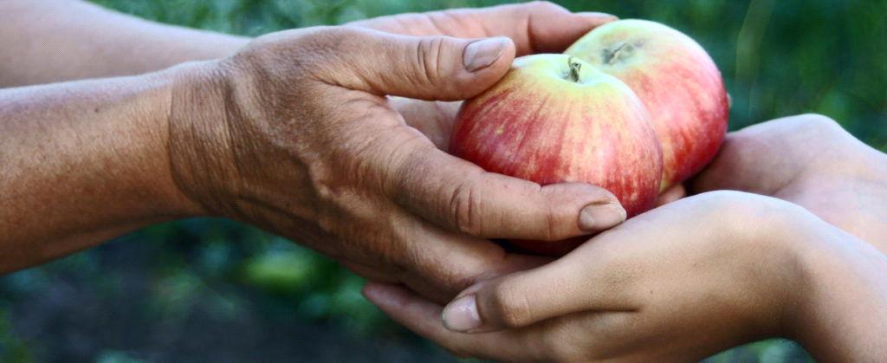

**2. Reduce Food Waste**

Food wastage starts right from the soil of the fields to the leftovers from restaurants and homes all across the world. Our aim is to reduce food wastage by providing means to donate it rather than disposing it off.

 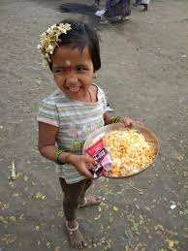

**3. Encourage sustainable farming method-organic farming**

We aim to collect non-edible food waste from restaurants and convert it into organic fertilizers and providing it for urban gardening.

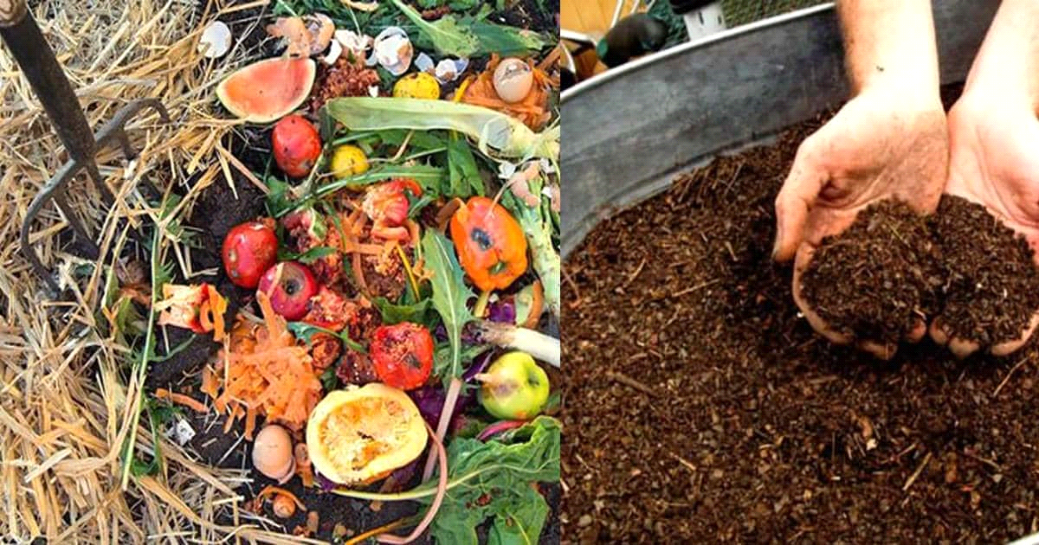

**DONATIONS: WE RISE BY LIFTING OTHERS**

**Donate Now.**

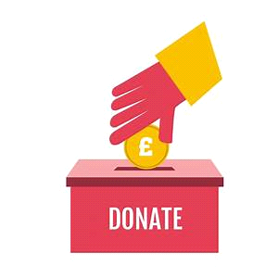

Provide NGO details here.